|  |  |
| --- | --- |
| **Student Name** | **Arun Adhikari** |
| **SRN No** | 202100406 |
| **Roll No** | 38 |
| **Program** | Computer Engineering |
| **Year** | Third Year |
| **Division** | G |
| **Subject** | Computer Network Laboratory (BTECCE21506) |
| **Assignment No** | Three |

**Title :** Subnetting and Supernetting in Computer Network

**Problem Statement :** Using a Network Simulator (e.g. packet tracer) Configure subnetting and supernetting.

**Theory :**

**Subnetting**

Subnetting is a technique used in computer networking to divide a larger IP network into smaller, more manageable sub-networks or subnets. It's a fundamental concept in IP addressing and is used to efficiently allocate IP addresses and manage network resources. Subnetting allows network administrators to create logical divisions within a larger network, helping to improve network performance, security, and organization.

**IP Address Classes:** IP addresses are categorized into classes: A, B, and C. Each class has a default subnet mask that determines the default network and host portions of the IP address.

**Subnet Mask**: A subnet mask is a 32-bit binary number that separates the IP address into network and host portions. It is usually represented in decimal-dotted format (e.g., 255.255.255.0).

**Subnetting:** To subnet a network, you borrow bits from the host portion of the IP address to create additional subnets. This increases the number of available subnets but reduces the number of available host addresses within each subnet.

**Subnet Size:** The size of a subnet is determined by the number of borrowed bits. The formula to calculate the number of usable host addresses in a subnet is 2^(number of host bits) - 2. The "-2" accounts for the network address (all host bits set to 0) and the broadcast address (all host bits set to 1).

**Benefits of Subnetting:**

Efficient IP Address Allocation: Subnetting prevents wastage of IP addresses, as you can allocate addresses more precisely based on your network's needs.

Improved Network Performance: Smaller subnets can reduce network congestion and improve the efficiency of communication.

Enhanced Security: Subnets can isolate different parts of a network, improving security by restricting the flow of traffic.

Simplified Management: Dividing a large network into smaller subnets makes it easier to manage and troubleshoot network issues.

**Important point about subnetting**

* A subnet is a smaller portion of large network treated as its own separate network. To create subnet we borrow bits from host portion and assign them as network bits. This mean more networks, fewer hosts.
* If the network bits on two addresses do not match, then the two packets are intended for two separate networks.
* On a 32 bits IP address at least eight bits must belong to the network portion and at least 2 bits must belong to the host portion.
* Each IP address has a predefined IP class and that cannot be changed.
* Each class has a predefined default subnet mask that tell us the octets, which are already part of the network portion, as well as how many bits we have available to work with.
* Whatever network class is it, we cannot change those bits that are already assigned.
* We cannot assign the network ID and the broadcast address to a host.
* Regardless how many bits are left in the host field, network ID and the broadcast address must be reserved.
* Subnet bits start at the left and go to the right, without skipping bits.

**Supernetting**

Supernetting is the opposite of Subnetting. In subnetting, a single big network is divided into multiple smaller subnetworks. In Supernetting, multiple networks are combined into a bigger network termed as a Supernetwork or Supernet.

Supernetting is mainly used in Route Summarization, where routes to multiple networks with similar network prefixes are combined into a single routing entry, with the routing entry pointing to a Super network, encompassing all the networks. This in turn significantly reduces the size of routing tables and also the size of routing updates exchanged by routing protocols. one reason we'd want to supernet is to reduce the size of your IP routing table to improve network routing efficiency. Another use case of supernetting is to merge a bunch of smaller subnets to create a larger network capable of accommodating a more hosts (attached devices). For example, supernetting can allow you to grow your maximum number of hosts on a subnetwork from 254 to 1022 after the merge.

More specifically,

* When multiple networks are combined to form a bigger network, it is termed as super-netting
* Supernetting is used in route aggregation to reduce the size of routing tables and routing table updates

**Case Study :**

**Write about the network you have implemented.**

* **Network Overview :**

This network is designed using the 192.168.10.x subnet, where multiple PCs are connected to switches, which are in turn connected to a router (model 2811). The router provides the inter-network communication. This setup represents a local area network (LAN) with a centralized router acting as the gateway for PCs.

* **Devices and Configuration :**

**Router (2811) :**

**IP Address: 192.168.10.3**

Acts as the central routing device between different subnets (if any were implemented).

Provides connectivity to external networks or other VLANs.

**Switch 0 (2960-24TT):**

Connected to PCs PC0 and PC1.

PC0: IP Address: 192.168.10.1

PC1: IP Address: 192.168.10.2

Ensures communication between the connected PCs and routes the data to the router.

**Switch 1 (2960-24TT):**

Connected to PC2 and PC3.

**PC2:** IP Address: 192.168.10.129

**PC3:** IP Address: 192.168.10.130

Similar to Switch 0, it facilitates the communication between the PCs connected to it.

**PCs (PC0 - PC3):**

Each PC has a unique IP address within the 192.168.10.x range.

They are connected to the switches, which provide LAN communication.

PCs can communicate with each other using ICMP (Ping) to verify network connectivity.

**Network Topology :**

The topology is a star topology, where each device is connected to a central device (switches), and the switches are connected to the router, forming a hierarchical structure.

This structure is scalable and easy to manage, where adding more devices requires only connecting them to the switch or expanding the network.

**Communication :**

The simulation shows ICMP (Ping) requests being successfully exchanged between the PCs (PC1 to PC3, PC0 to PC1), indicating that the network is configured properly and devices are able to communicate with each other. This is essential in real-world scenarios to ensure that the devices on the LAN can share data efficiently.

**Key Features of the Network :**

**Efficient Communication** : All devices can communicate with each other, thanks to proper subnetting and the use of switches.

**Scalability :** The setup allows for easy addition of more PCs or network devices by simply connecting them to the available switches or expanding to another switch.

**Centralized Routing** : The router is positioned to control data traffic within the network and can be used to connect to external networks if needed.

**Subnets :** While not explicitly shown, the network could potentially be divided into multiple subnets in the future by configuring additional interfaces on the router.

**Problem :**

**1. Default Subnet (255.255.255.0 or /24)**

If your network uses a /24 subnet mask, the 192.168.10.0/24 subnet has the following properties:

**Network ID :** 192.168.10.0

**Usable Host Range :** 192.168.10.1 to 192.168.10.254

**Broadcast Address :** 192.168.10.255

In this scenario, all your devices are part of the same network, and the available IP range is from 192.168.10.1 to 192.168.10.254.

**2. Subdividing into Smaller Subnets**

If you need to divide the network into multiple subnets (e.g., for organizational reasons or to separate devices into logical groups), you'll use a smaller subnet mask. Here's how the ranges break down for some common subnet masks:

**a) /25 Subnet Mask (255.255.255.128)**

This divides the 192.168.10.0/24 network into two subnets:

**Subnet 1: 192.168.10.0/25**

**Network ID :** 192.168.10.0

**Usable Host Range :** 192.168.10.1 to 192.168.10.126

**Broadcast Address :** 192.168.10.127

**Subnet 2 : 192.168.10.128/25**

**Network ID :** 192.168.10.128

**Usable Host Range :** 192.168.10.129 to 192.168.10.254

**Broadcast Address :** 192.168.10.255

In this case, PCs connected to Switch 0 (with addresses like 192.168.10.1 and 192.168.10.2) would fall under the first subnet. PCs connected to Switch 1 (with addresses like 192.168.10.129 and 192.168.10.130) would fall under the second subnet.

**b) /26 Subnet Mask (255.255.255.192)**

This further divides the network into four subnets:

**Subnet 1:** 192.168.10.0/26

**Network ID :** 192.168.10.0

**Usable Host Range :** 192.168.10.1 to 192.168.10.62

**Broadcast Address :** 192.168.10.63

**Subnet 2:** 192.168.10.64/26

**Network ID:** 192.168.10.64

**Usable Host Range:** 192.168.10.65 to 192.168.10.126

**Broadcast Address:** 192.168.10.127

**Subnet 3:** 192.168.10.128/26

**Network ID:** 192.168.10.128

**Usable Host Range:** 192.168.10.129 to 192.168.10.190

**Broadcast Address:** 192.168.10.191

**Subnet 4:** 192.168.10.192/26

**Network ID:** 192.168.10.192

**Usable Host Range:** 192.168.10.193 to 192.168.10.254

**Broadcast Address:** 192.168.10.255

**c) /27 Subnet Mask (255.255.255.224)**

**This would divide the network into even smaller subnets, each with fewer hosts:**

**Subnet 1:** 192.168.10.0/27

**Usable Host Range:** 192.168.10.1 to 192.168.10.30

**Subnet 2**: 192.168.10.32/27

**Usable Host Range:** 192.168.10.33 to 192.168.10.62

**Subnet 3:** 192.168.10.64/27

**Usable Host Range:** 192.168.10.65 to 192.168.10.94

**Switch 0:**

**PC0:** 192.168.10.1

**PC1:** These PCs seem to belong to the 192.168.10.0/25 subnet (first half of the /24 network).

**Switch 1:**

**PC2:** 192.168.10.129 192.168.10.2

**PC3:** 192.168.10.130

These PCs seem to belong to the 192.168.10.128/25 subnet (second half of the /24 network).

**Solution :**

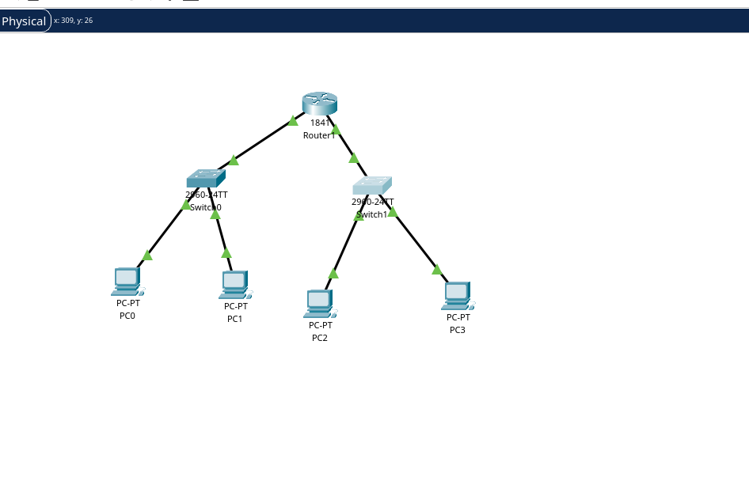

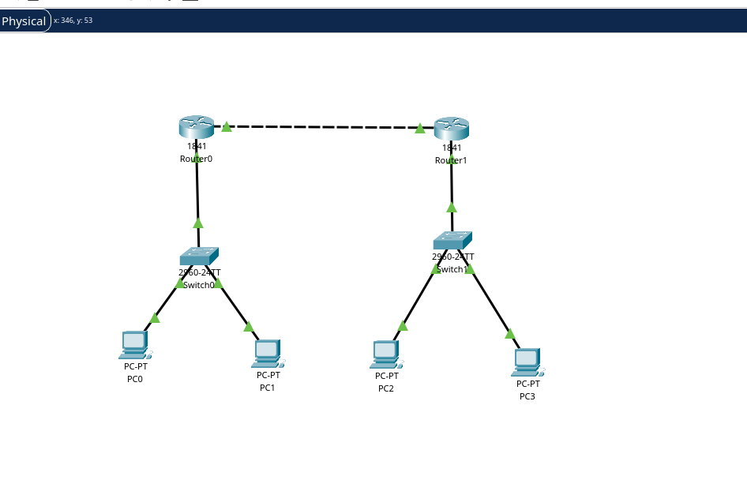

**Conclusion :**

This network is well-suited for small to medium-sized environments such as a small office or classroom where devices need to communicate internally with a central router providing network services. The use of ICMP indicates that the connections are stable, and the devices are properly communicating over the network.